Resultados do Impacto da Rede sem fio em FA

1. Análise Centralizada

Query: What are the current top 3 most popular songs?

Resultados:
The top 3 most popular songs are:
1. Dance Monkey - Tones and I (latin)
2. Dance Monkey - Tones and I (pop)
3. ROXANNE - Arizona Zervas (latin)
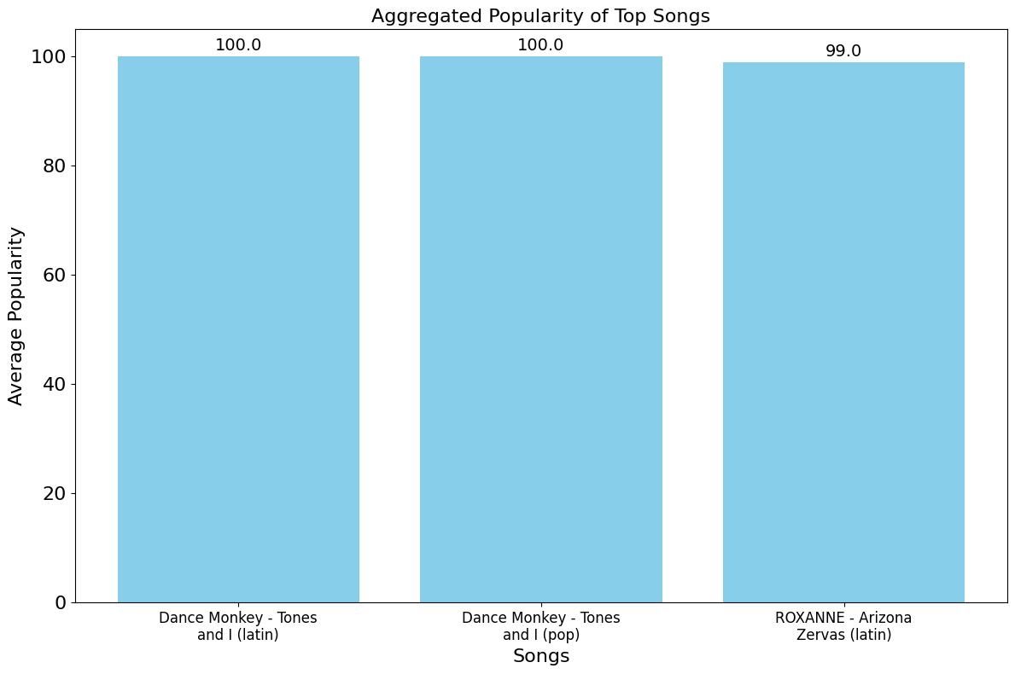

2. Análise Federada
Caso 1: 100% de clientes transmitem as suas respostas para o servidor

Number of selected Clients: 10/10

Query: What are the current top 3 most popular songs?

Resultados:
The aggregated top 3 most popular songs are:
1. Dance Monkey - Tones and I (latin)
2. Dance Monkey - Tones and I (pop)
3. ROXANNE - Arizona Zervas (latin)

Caso 2: 75% de clientes transmitem as suas respostas para o servidor

Number of selected Clients: 8/10

Query: What are the current top 3 most popular songs?

Resultados:
The aggregated top 3 most popular songs are:
1. Dance Monkey - Tones and I (latin)
2. Dance Monkey - Tones and I (pop)
3. ROXANNE - Arizona Zervas (latin)

Caso 3: 50% de clientes transmitem as suas respostas para o servidor

Number of selected Clients: 5/10

Query: What are the current top 3 most popular songs?

Resultados:
The aggregated top 3 most popular songs are:
1. Dance Monkey - Tones and I (latin)
2. Dance Monkey - Tones and I (pop)
3. ROXANNE - Arizona Zervas (latin)

Caso 4: 25% de clientes transmitem as suas respostas para o servidor

Number of selected Clients: 3

Query: What are the current top 3 most popular songs?

The aggregated top 3 most popular songs are:
1. The Box - Roddy Ricch (rap)
2. Tusa - KAROL G (rap)
3. Blinding Lights - The Weeknd (pop)
